Санкт-Петербургский политехнический университет Петра Великого

Институт компьютерных наук и технологий

Кафедра компьютерных систем и программных технологий

**Отчет по лабораторной работе №1**

по дисциплине «SystemC»

Проектирование сдвигающего регистра и счетчика

Выполнил

студент гр. 13541/2

Никитенко А.П.

Преподаватели

Петров М.А.

Мамутова О.В.

**Цель работы**: разработка счетчика и сдвигающего регистра на языке SystemC согласно варианту и проведение тестирования.

**Ход работы.**

Основные входы/выходы счетчика:

* clk
* areset
* sreset_n
* dout

Основные входы/выходы сдвигающего регистра:

* clk
* areset
* sreset
* cin
* cout
* dout

Таблица дополнительных функций устройств (Вариант 4).

|  |  |  |  |  |  |  |
| --- | --- | --- | --- | --- | --- | --- |
| № п/п | counter | | | shift_register | | |
| ena | load | up/down | ena | load | left/right |
| **4** |  | **+** |  |  |  | **+** |

Реализация сдвигающего регистра и счетчика представлена в файлах shift_reg.h, shift_reg.cpp(Приложение 1) и counter.h, counter.cpp соответственно(Приложение 2).

Результаты тестирования для обоих устройств были сгенерированы в .vcd файл и совпадают с ожидаемыми результатами.

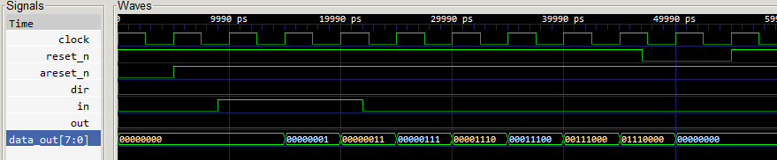 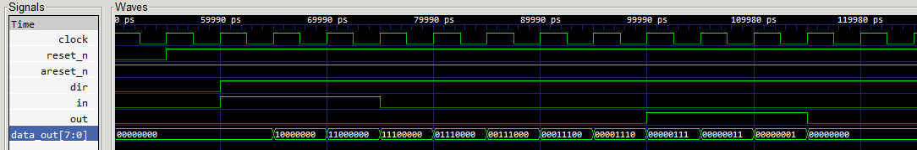

Рис. 2. Результат тестирования сдвигающего регистра

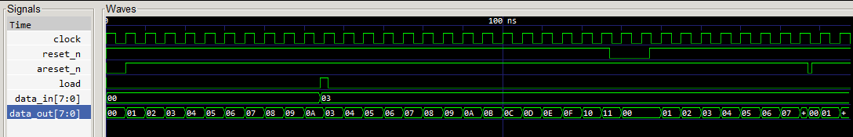

Рис.3. Результат тестирования счетчика

Приложение 1

**shift_reg.h**

#ifndef SHIFT_REG_H

#define SHIFT_REG_H

#include <systemc.h>

SC_MODULE(shift_reg) {

sc_in_clk clock; // Clock input of the design

sc_in<bool> reset_n; // negative high, synchronous Reset input

sc_in<bool> areset_n; //asynchronous reser, negative high

sc_in<bool> dir;

sc_in<bool> in; //bit input

sc_out<sc_uint<8> > data_out; // 8 bit vector input

sc_out<bool> out; // output

//------------Local Variables Here---------------------

sc_signal<sc_uint<8>> data;

//------------Code Starts Here-------------------------

// Below function implements actual register logic

void shift();

//Constructor

SC_CTOR(shift_reg) :

clock("clock"),

reset_n("reset_n"),

areset_n("areset_n"),

dir("dir"),

data_out("data_out"),

out("out") {

SC_CTHREAD(shift, clock.pos());

reset_signal_is(reset_n, false);

async_reset_signal_is(areset_n, false);

} // End of Constructor

}; // End of Module

#endif // SHIFT_REG_H

**shift_reg.cpp**

#include "shift_reg.h"

void shift_reg::shift() {

// We check if reset is active

data = 0;

data_out = 0;

out = 0;

wait();

while (true) {

if(dir==false){

data.write((data.read().range(6, 0), in.read()));

data_out.write(data.read());

out = (bool)data.read().bit(7);

}

else {

data.write((in.read(),data.read().range(7, 1)));

data_out.write(data.read());

out = (bool)data.read().bit(0);

}

cout << "@" << sc_time_stamp() << " :: Have stored " << data_out.read() << endl;

wait();

}

}

**testbench.cpp**

#include "systemc.h"

#include "shift_reg.h"

int sc_main(int argc, char* argv[])

{

sc_clock clock("clock", 5, SC_NS);

sc_signal<bool> reset_n;

sc_signal<bool> areset_n;

sc_signal<bool> dir;

sc_signal<sc_uint<8>> data;

sc_signal<bool> in;

sc_signal<sc_uint<8>> data_out;

sc_signal<bool> out;

// Connect the DUT

shift_reg shift_reg_test("shift_reg");

shift_reg_test.clock(clock);

shift_reg_test.reset_n(reset_n);

shift_reg_test.areset_n(areset_n);

shift_reg_test.dir(dir);

shift_reg_test.in(in);

shift_reg_test.data_out(data_out);

shift_reg_test.out(out);

// Open VCD file

sc_trace_file *wf = sc_create_vcd_trace_file("shift_reg_waveform");

// Dump the desired signals

sc_trace(wf, clock, "clock");

sc_trace(wf, reset_n, "reset_n");

sc_trace(wf, areset_n, "areset_n");

sc_trace(wf, dir, "dir");

sc_trace(wf, in, "in");

sc_trace(wf, data_out, "data_out");

sc_trace(wf, out, "out");

dir = 0;

in = 0;

reset_n = 1;

areset_n = 0;

cout << "@" << sc_time_stamp() << " Asserting async reset_n\n" << endl;

sc_start(5, SC_NS);

areset_n = 1;

sc_start(4, SC_NS);

in = 1;

sc_start(1, SC_NS);

sc_start(5, SC_NS);

assert(data_out.read() == 0);

sc_start(5, SC_NS);

assert(data_out.read() == 1);

sc_start(2, SC_NS);

in = 0;

sc_start(3, SC_NS);

assert(data_out.read() == 3);

sc_start(5, SC_NS);

assert(data_out.read() == 7);

sc_start(5, SC_NS);

assert(data_out.read() == 0x0e);

sc_start(5, SC_NS);

assert(data_out.read() == 0x1c);

sc_start(5, SC_NS);

assert(data_out.read() == 0x38);

sc_start(2, SC_NS);

int tmp = data_out.read();

cout << endl << "tmp = " << tmp << endl;

reset_n = 0;

sc_start(1, SC_NS);

assert(data_out.read() == tmp);

sc_start(4, SC_NS);

assert(data_out.read() == 0);

sc_start(3, SC_NS);

reset_n = 1;

sc_start(5,SC_NS);

dir=1;

in=1;

sc_start(5,SC_NS);

assert(data_out.read()==0x00);

sc_start(5,SC_NS);

assert(data_out.read()==0x80);

sc_start(5,SC_NS);

assert(data_out.read()==0xc0);

in=0;

sc_start(5,SC_NS);

assert(data_out.read()==0xe0);

sc_start(5,SC_NS);

assert(data_out.read()==0x70);

for(int i = 0; i<15; i++) sc_start(5, SC_NS);

cout << "@" << sc_time_stamp() << " Terminating simulation\n" << endl;

sc_close_vcd_trace_file(wf);

return 0;

}

Приложение 2

**counter.h**

#include "systemc.h"

#ifndef COUNTER_H

#define COUNTER_H

SC_MODULE(counter) {

sc_in_clk clock; // Clock input of the design

sc_in<bool> reset_n; // negative high, synchronous Reset input

sc_in<bool> areset_n; //asynchronous reser, negative high

sc_in<bool> load;

sc_in<sc_uint<8> > data_in; // 8 bit vector input

sc_out<sc_uint<8> > data_out; // 8 bit vector output

//------------Local Variables Here---------------------

sc_uint<8> reg;

//------------Code Starts Here-------------------------

// Below function implements actual register logic

void count();

//Constructor

SC_CTOR(counter) :

clock("clock"),

reset_n("reset_n"),

areset_n("areset_n"),

load("load"),

data_in("data_in"),

data_out("data_out") {

cout << "Start Executing" << endl;

SC_CTHREAD(count, clock.pos());

reset_signal_is(reset_n, false);

async_reset_signal_is(areset_n, false);

} // End of Constructor

}; // End of Module

#endif

#include "counter.h"

void counter::count() {

// We check if reset is active

reg = 0;

data_out.write(reg);

wait();

while (true) {

if(load) reg = data_in.read();

else reg +=1;

cout << "@" << sc_time_stamp() << " :: Have stored " << reg << endl;

data_out.write(reg);

wait();

}

}

**testbench.cpp**

#include "systemc.h"

#include "counter.h"

int sc_main(int argc, char* argv[])

{

sc_clock clock("clock", 5, SC_NS);

sc_signal<bool> reset_n;

sc_signal<bool> areset_n;

sc_signal<bool> load;

sc_signal<sc_uint<8>> data_in;

sc_signal<sc_uint<8>> data_out;

// Connect the DUT

counter test_counter("test_counter");

test_counter.clock(clock);

test_counter.reset_n(reset_n);

test_counter.areset_n(areset_n);

test_counter.load(load);

test_counter.data_in(data_in);

test_counter.data_out(data_out);

// Open VCD file

sc_trace_file *wf = sc_create_vcd_trace_file("counter_waveform");

// Dump the desired signals

sc_trace(wf, clock, "clock");

sc_trace(wf, reset_n, "reset_n");

sc_trace(wf, areset_n, "areset_n");

sc_trace(wf, load, "load");

sc_trace(wf, data_in, "data_in");

sc_trace(wf, data_out, "data_out");

data_in = 0;

load = 0;

reset_n = 1;

areset_n = 0;

cout << "@" << sc_time_stamp() << " Asserting async reset_n\n" << endl;

sc_start(5, SC_NS);

areset_n = 1;

for (int i=0; i<9; i++){

sc_start(5, SC_NS);

assert(data_out.read() == i+1);

}

sc_start(4, SC_NS);

data_in = 3;

load = 1;

sc_start(2, SC_NS);

load = 0;

sc_start(2, SC_NS);

assert(data_out.read() == 3);

sc_start(2, SC_NS);

for (int i=0; i<13; i++){

sc_start(5, SC_NS);

assert(data_out.read() == i+4);

}

sc_start(2, SC_NS);

int tmp = data_out.read();

cout << endl << "tmp = " << tmp << endl;

reset_n = 0;

sc_start(5, SC_NS);

assert(data_out.read() == 0);

sc_start(5, SC_NS);

reset_n = 1;

for (int i=0; i<7; i++){

sc_start(5, SC_NS);

}

sc_start(5, SC_NS);

areset_n = 0;

sc_start(1, SC_NS);

assert(data_out.read() == 0);

areset_n = 1;

sc_start(10, SC_NS);

cout << endl;

cout << "@" << sc_time_stamp() << " Terminating simulation\n" << endl;

sc_close_vcd_trace_file(wf);

return 0;

}